## **Project Overview**

The Mbabane Highlanders AM Web App plays as a **digital flagship platform** connecting the club with supporters in local and international environment .  
 It gives a centralized hub for membership management, ticketing, merchandise, fan engagement, and club communication — empowering the Highlanders to be a **digitally advanced African football brand**.

## **Strategic Vision**

The platform goal is to:

* Give secure and safe digital membership ID cards for supporters.
* Offer online ticketing and merchandise sales.
* Create an interactive fan zon**e** with exclusive content and community features.
* Improve sponsorship visibility through a professional digital presence.
* Deliver data-driven insights to club management.

**Core Technologies**

|  |  |
| --- | --- |
| **Layer** | **Technologies** |
| **Backend** | .NET Core |
| **Database** | MySQL |
|  |  |
| **Frontend** | HTML5, CSS3, React.js (Responsive Design) |
| **Hosting** | Plesk |
| **Integrations** | WhatsApp API, Email Notifications |
| **Payments** | Payfast |

**Key Features**

### **For Supporters**

* Online registration and instant digital membership card
* Mobile-friendly fan zone with news, fixtures, and interactive content
* Online **store** for tickets and merchandise
* Personalized dashboard for renewals and updates

### **For Club Management**

* Admin portal is for membership and payment management
* Automated subscription tracking
* Easy tools for posting news, match schedules, and updates
* Analytics dashboard for insights and engagement tracking

**User Flows**

### **Supporter Flow**

1. Visit the site and register online
2. Complete payment (payfast)
3. Instantly receive a **digital membership card**
4. Unlock access to **exclusive content and fan zone**
5. Purchase **tickets and merchandise**

### **Administrator Flow**

1. Log in to the **admin dashboard**
2. Basically Approve memberships and monitor payments
3. Manage fixtures, content, and merchandise
4. Track engagement and generate reports
5. Oversee ticket sales and stock levels

## **Revenue Model**

* Membership subscriptions
* Online ticket and merchandise sales
* Sponsorship placements and digital advertising

## **Community Impact**

* Promotes **digital inclusion** in Eswatini’s football ecosystem
* Strengthens the Highlanders’ **cultural identity** by using technology
* Encourages **youth engagement** and digital literacy

## **Success Metrics**

* Online membership registrations
* Adoption of digital membership cards
* Growth in merchandise and ticket sales
* Fan engagement metrics in the fan zone
* Sponsorship and advertising revenue
* System reliability and uptime

## **Setup and Installation Guide**

### **Backend Setup (.NET Core)**

To run the backend API, you need follow these steps:

1. **Install Required Software**
   1. Download and install the **.NET SDK (v6 or later)**.
   2. Install **MySQL Server** and make sure it is running on your system.
2. **Configure the Backend Project**
   1. Open the backend project folder in your IDE ( VS Code).
   2. Update the **database connection string** with your MySQL credentials (database name, username, and password).
3. **Apply Migrations**
   1. Run the database migrations to create all necessary tables for the project.
4. **Run the Backend Server**
   1. Start the backend server to launch the API.
5. **Verify API Functionality**
   1. Open your browser or API testing tool and go to your local host (e.g., [**http://localhost:5000**](http://localhost:5000)) to confirm the backend is running successfully.

### **Frontend Setup (React.js)**

To run the frontend interface, you need follow these steps:

1. **Install Required Software**
   1. Install **Node.js (v16 or later)** and ensure **npm** is available on your system.
2. **Open the Frontend Project Directory**
   1. Navigate to the folder where the React.js project is located.
3. **Install Dependencies**
   1. Use npm to install all the required project dependencies.
4. **Connect to the Backend API**
   1. Add your backend API URL to the environment configuration file so the frontend can communicate with the backend (e.g., <http://localhost:5000>).
5. **Start the Development Server**
   1. Run the frontend development server.
6. **Access the Web App**
   1. Open your browser and go to [**http://localhost:3000**](http://localhost:3000) to view the website.

**Screenshots**

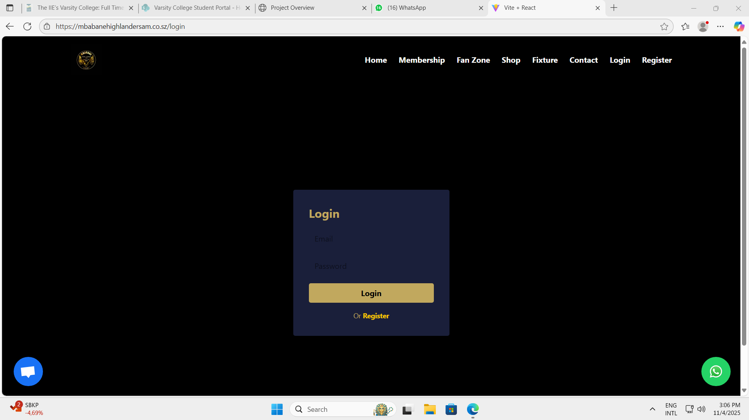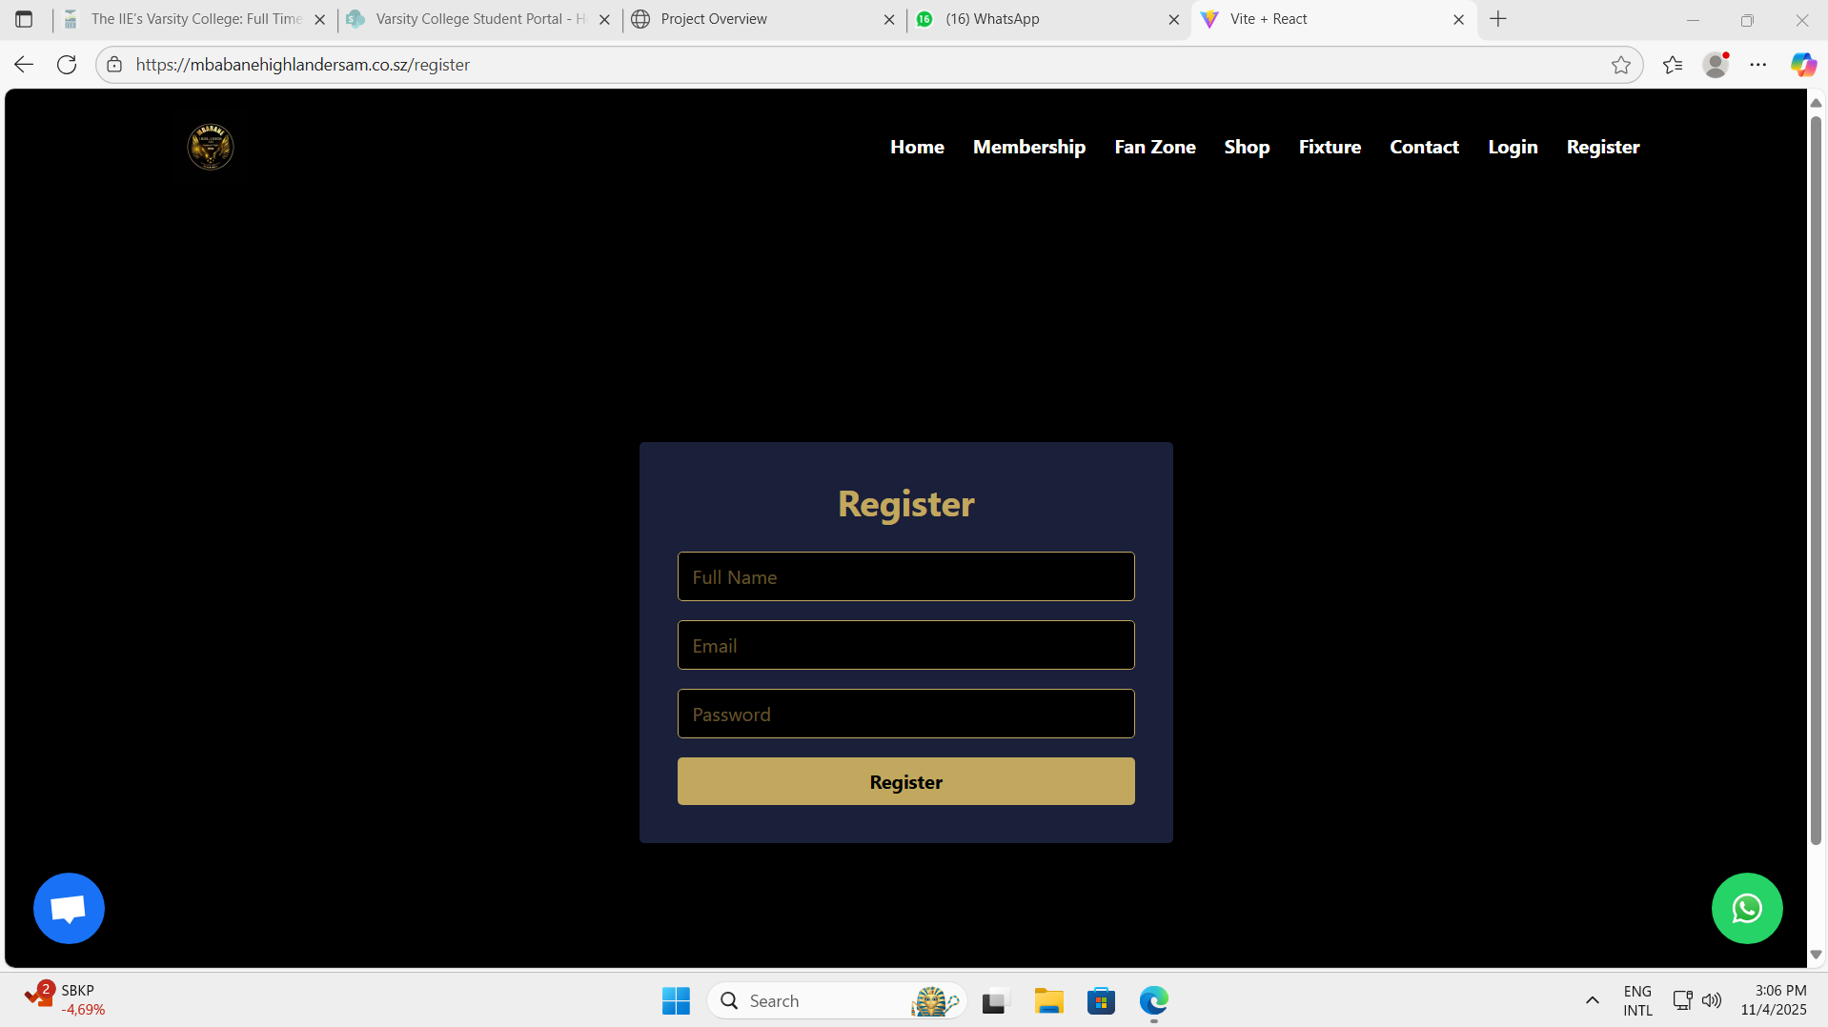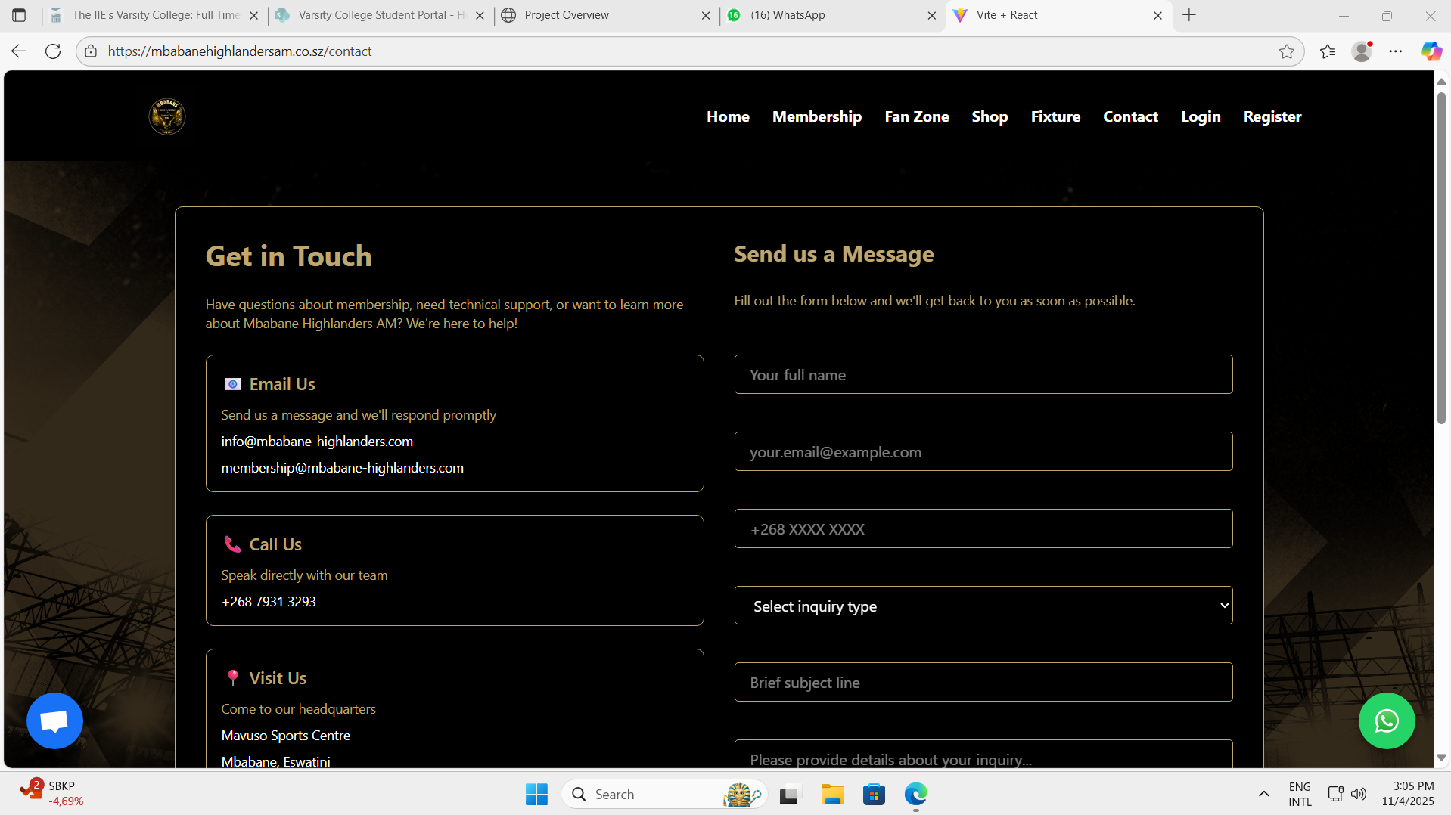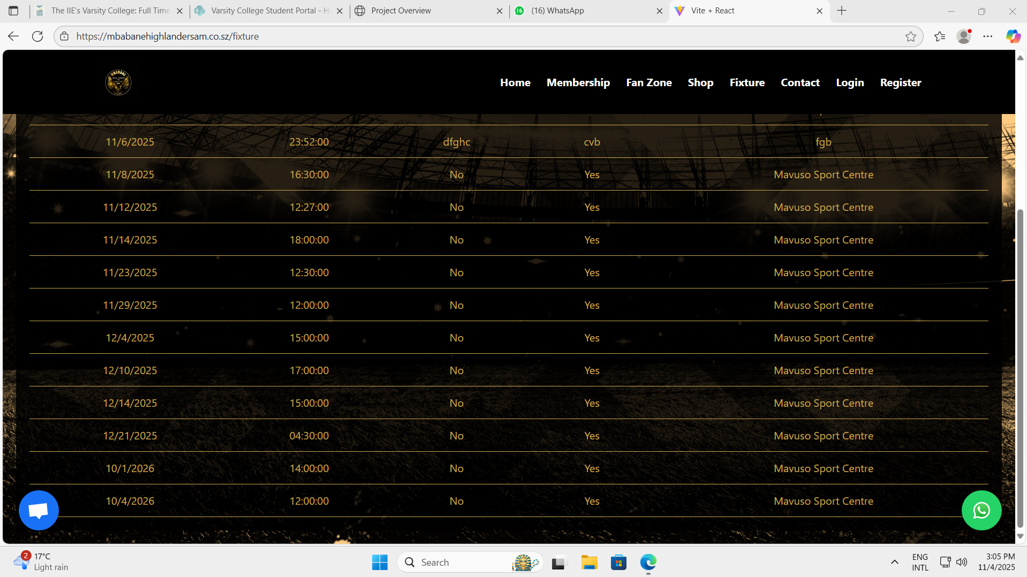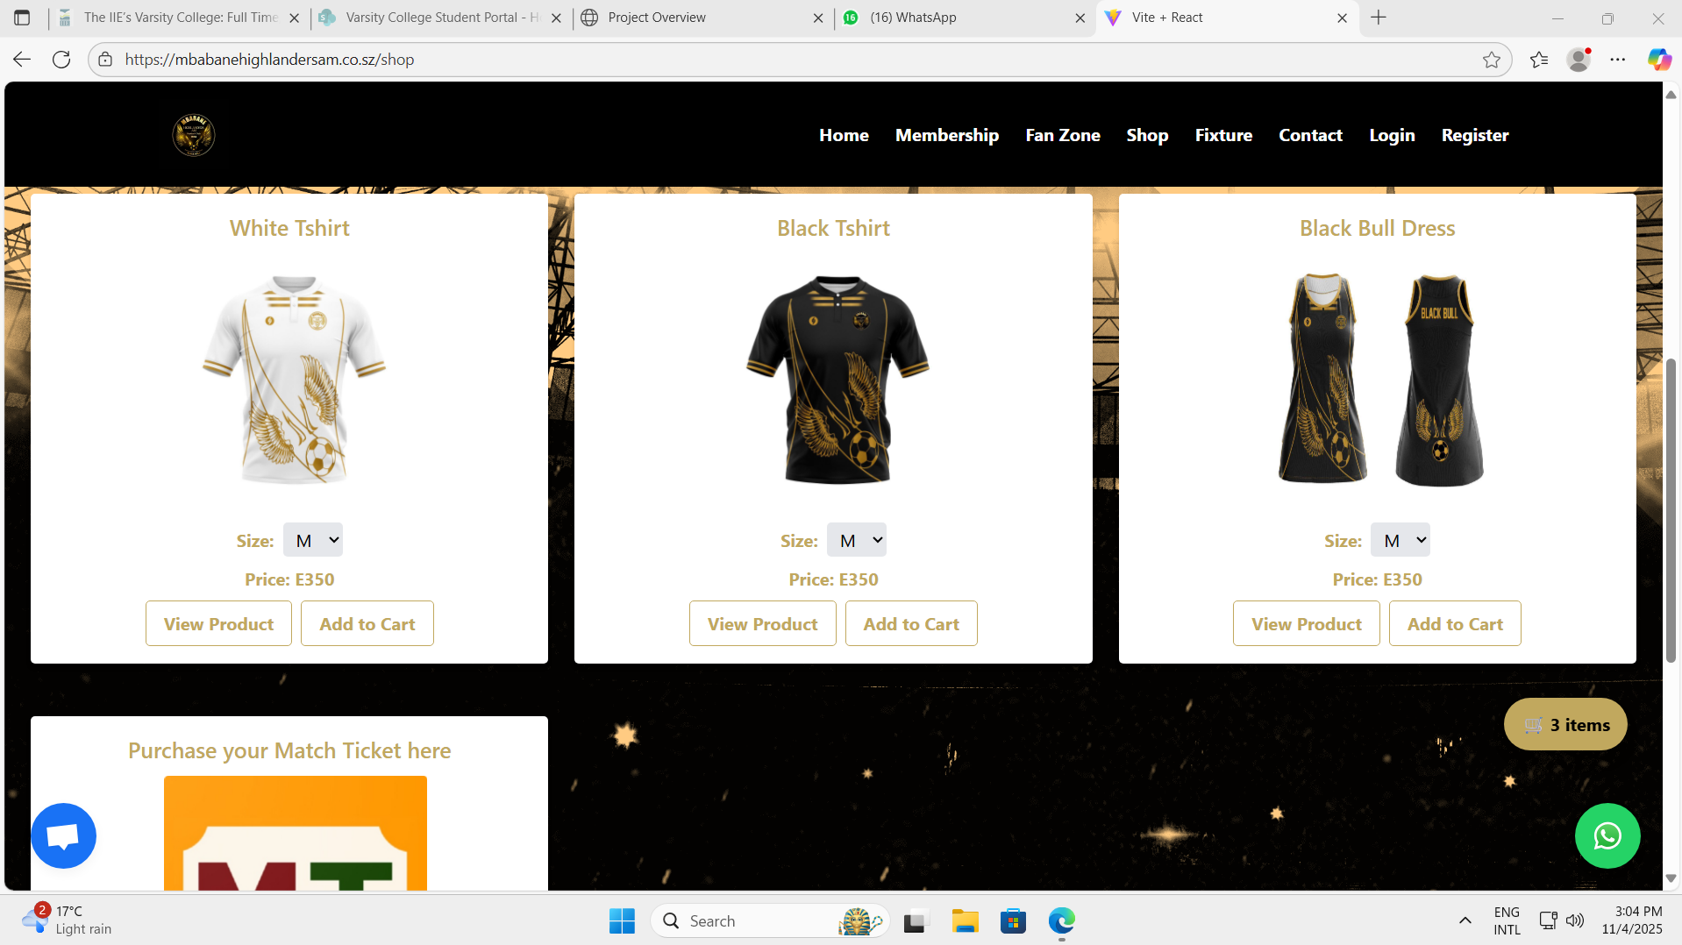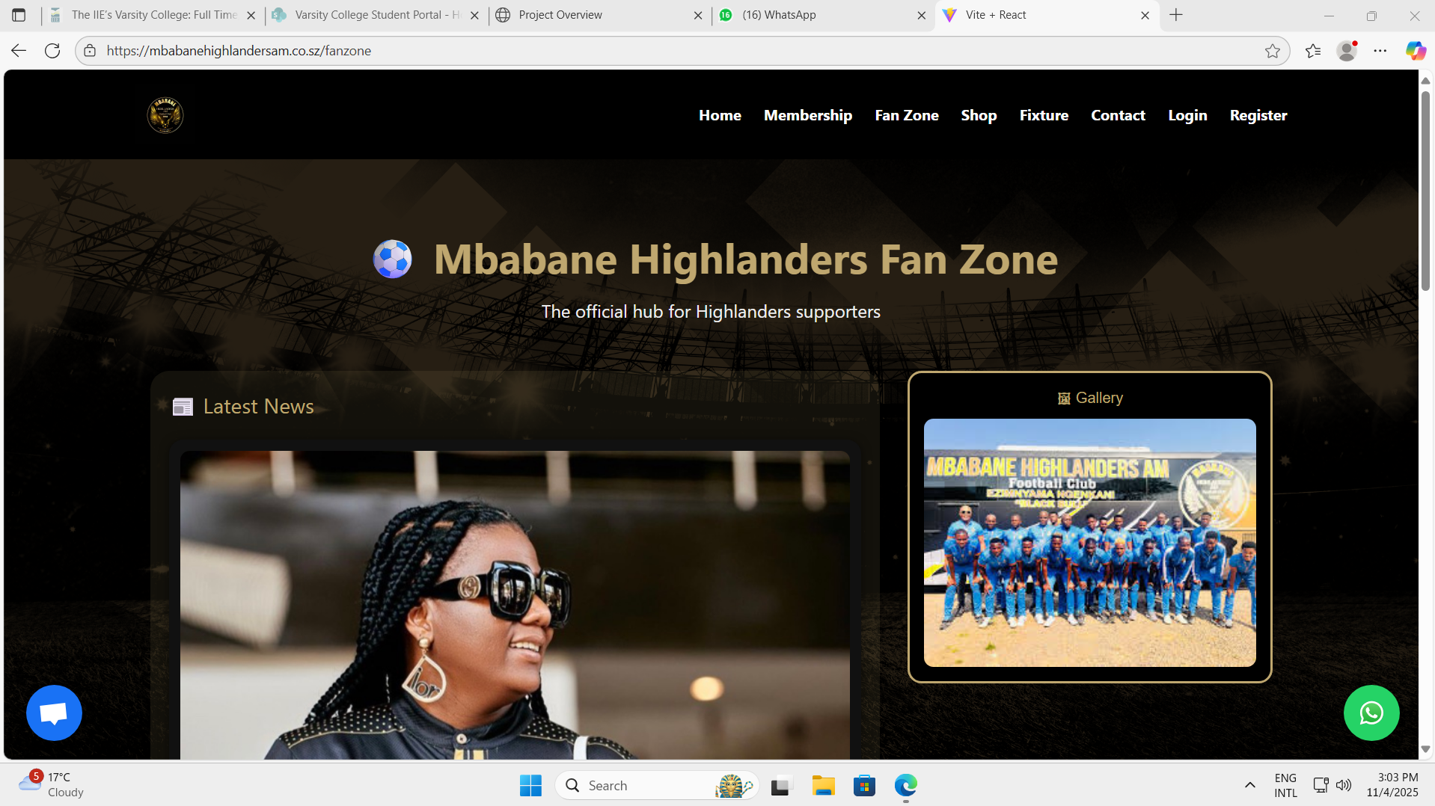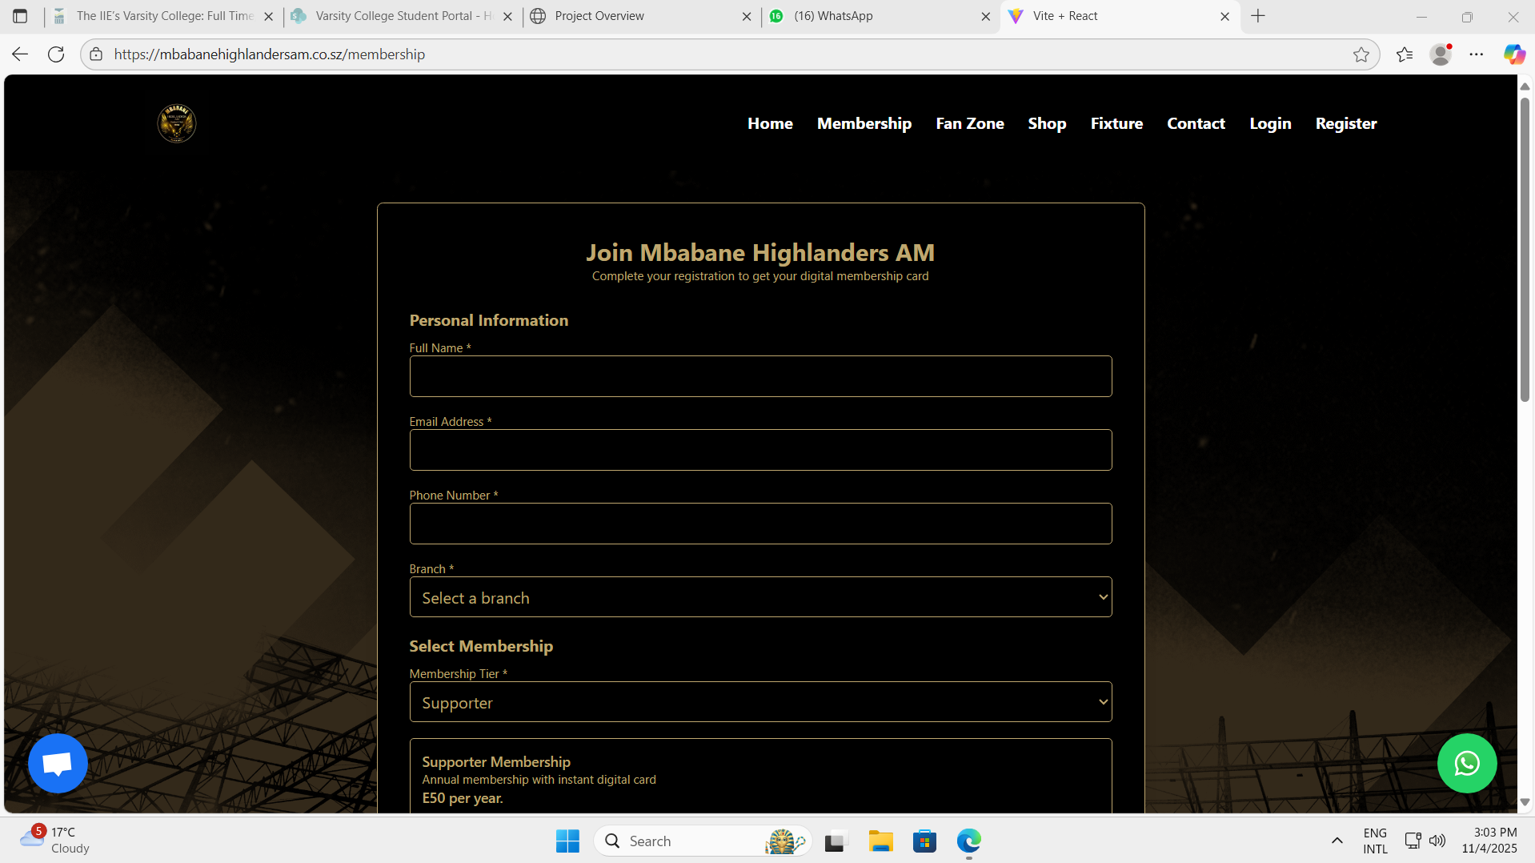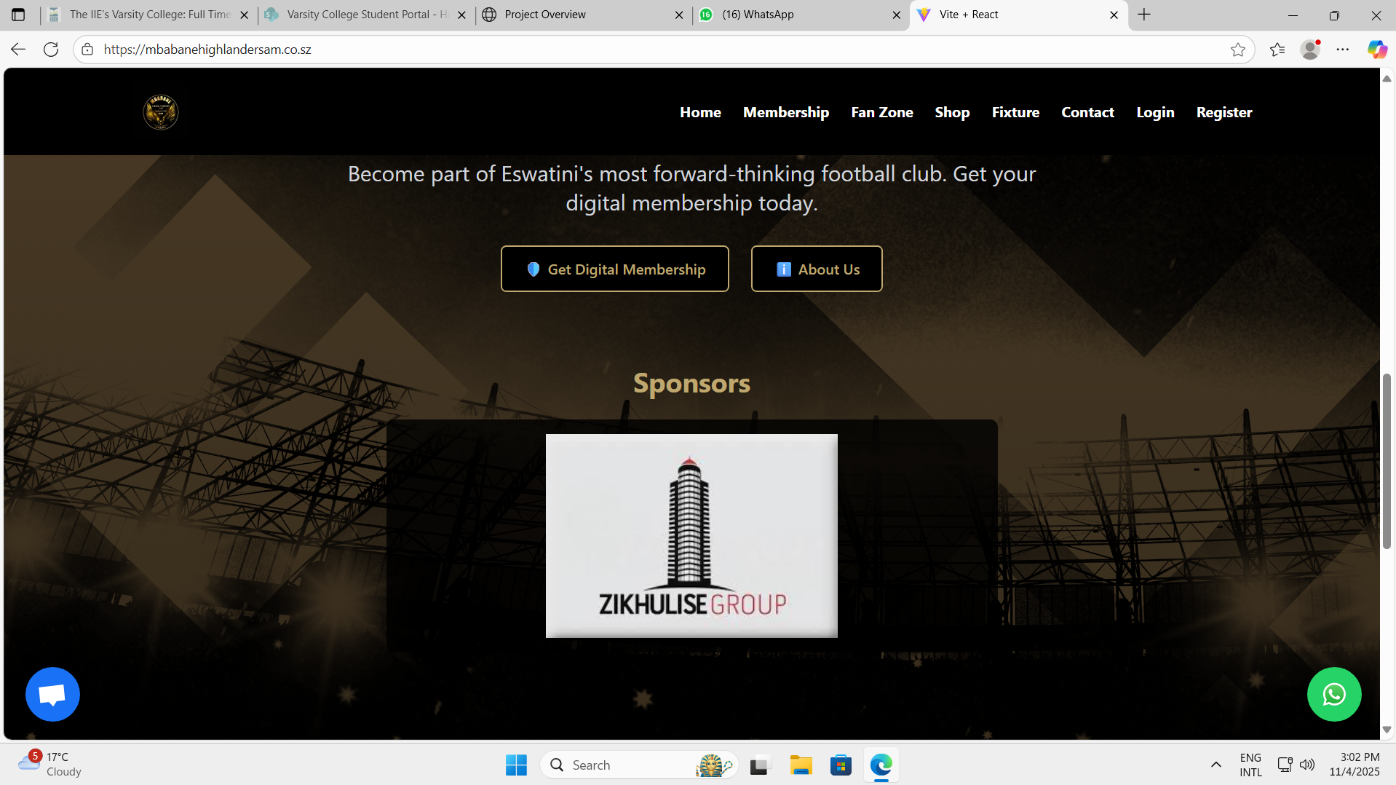

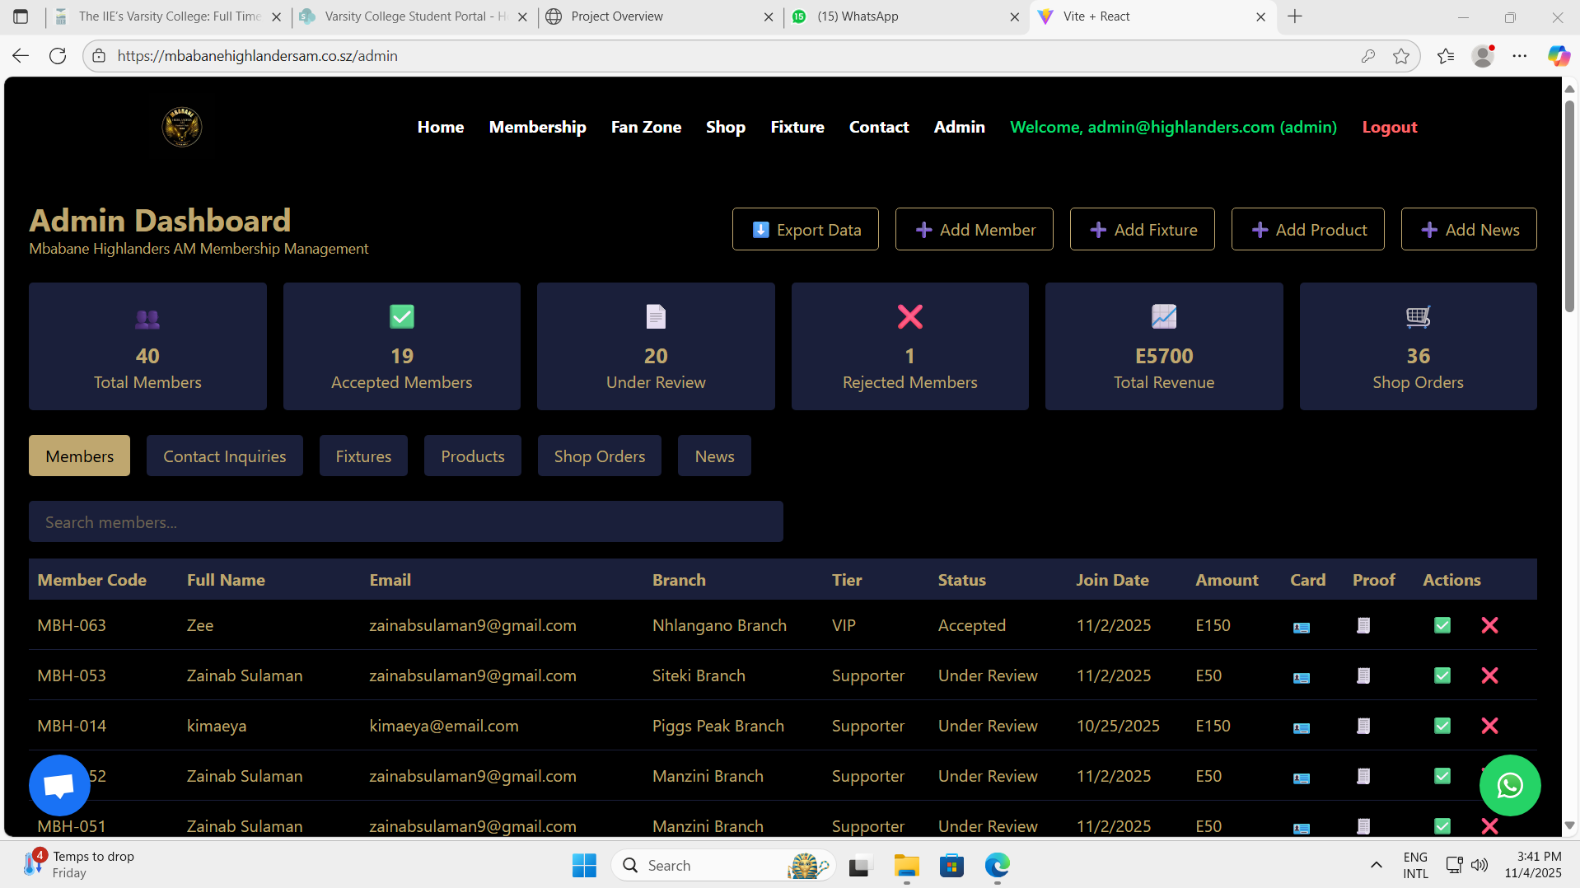

Explain the screenshots

**Home Page**

**What fans can do:**

* Explore current news, match results, and team updates.
* Use the navigation menu to move to other pages such as Registration, Login, Store, or Fan Zone.
* Stay informed about announcements and events without needing to log in.

**Login Page**

**What fans can do:**

* Log in to their personal supporter accounts using their registered credentials.
* Once logged in, gain access to the Fan Zone, Supporter Dashboard, and exclusive content.

**Registration Page**

**What fans can do:**

* Put their details (name, contact info, and password).

**Fan Zone**

**What fans can do:**

* Access members-only posts, match insights, and multimedia content.
* Participate in interactive polls or discussions.
* View upcoming match information and personalized updates.
* Interact with the club digitally — improving the fan experience.

**Online Store**

**What fans can do:**

* look through products and view detailed descriptions.
* Add items to their cart.
* Complete checkout through a **secure payment gateway**.
* Receive confirmation of their purchases via email or their dashboard.

**Admin Dashboard**

**What fans can do:**

* This section is blocked to fans.
* Club administrators use this portal to approve memberships, update fixtures, manage products, and monitor analytics.